The Manhasset Women’s Coalition Against Breast Cancer Outreach Program invites you to join us at:

CROCK POT CREATIONS
with Holistic Chef Christine Borzell
at Kitchen Designs by Ken Kelly

in this class you will learn:
- The best slow cooker ingredients & techniques for successful meals.
- How to cook once and eat twice with basic recipes and variations.
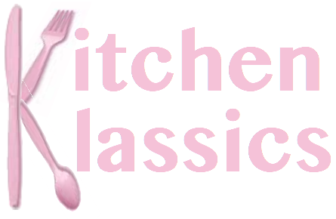
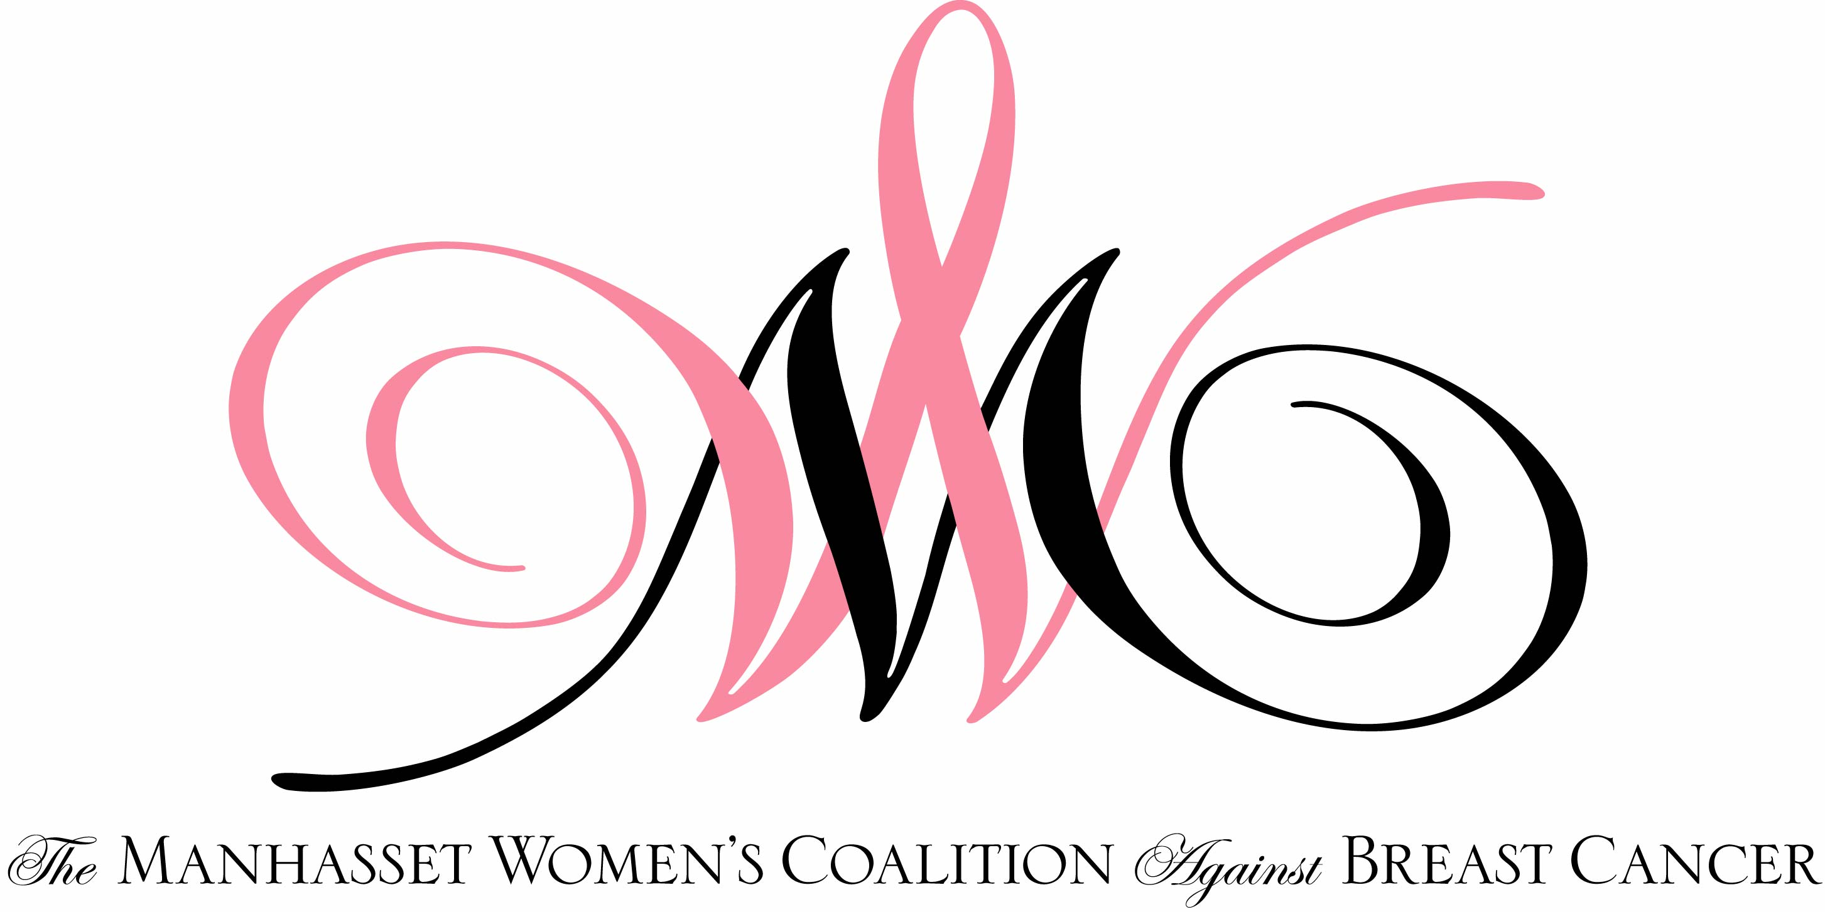
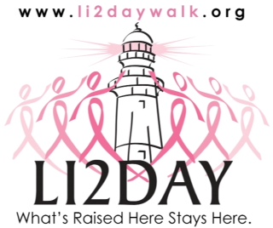
- How to make the most of your slow cooker with recipes for soups, stews, sauces and vegetarian meals.

DATE & TIME - Tuesday, February 4, 2014 from 7:30-9:30

PLACE - Kitchen Designs, 26 Hillside Avenue, Williston Park, NY

COST - $30.00 paid in advance - only 15 spots available

RSVP - Lynn Minutillo - lynnminutillo@verizon.net or 516-365-1032
you will be notified if you are one of the first 15 to RSVP

Future Programs :
Tuesday, March 4, 2014 - Flavor Infusion
Tuesday, April 8, 2014 - Glorious Grains

This program is made possible in part due to grants received from the
LI2Day Walk to Fight Breast Cancer

